*Occupational Safety and Health Training*

92d/141st Air Refueling Wing

Fairchild AFB, Washington

*Enter Workplace Name Here*

Job Safety Training Outline

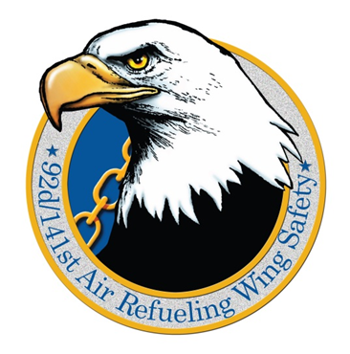

Updated: November 2024

Job Safety Training Outline (JSTO): DAFI 91-202, para 14.1

**The purpose** of this training is to advise employees of the requirements of Air Force Occupational Safety Program, in accordance with DAFI 91-202. Supervisors will provide and document safety training to all newly assigned individuals (i.e., PCS, PCA or work center change to include deployment) on the hazards of their job before they start work and immediately when there is a change in equipment, processes, work environment or safety, fire and health requirements. Refresher training will be conducted and documented when employees demonstrate a lack of understanding of their required safety responsibilities or training such as is called for in DAFMAN 91-203, Chapter 21, Hazardous Energy Control, has a specified frequency for recurrence.

***Note:*** IAW DAFI 91-202, para 1.6.28.4.6 supervisors will ensure any hazards identified by an AF Form 1118, Notice of Hazard, are added to the JSTO and employees are trained on the interim control measures and documented IAW paragraph 14.1, Job Safety Training Outline (JSTO).

**Supervisors will** review and update the JSTO annually and/or when there is a change in equipment, processes or safety, fire and health requirements, to include procedural input as a result of a completed JHA. JSTO reviews will be accomplished by the supervisor and documented with the date of review and the person conducting the review. Safety, fire protection and health personnel will provide technical assistance to supervisors in developing a training outline to meet AFI/AFOSH requirements. JSTOs will be reviewed by safety inspectors during the scheduled safety assessment.

**Document** safety, fire and health training as specified in paragraph 1.6.28.7 Documentation will be maintained by the supervisor within the work center.

**General Safety Education and Training Courses** are listed in tables 14.2 thru 14.12 Supervisors/instructors will document employee training.

Mandatory Items: DAFI 91-202, para 14.1.2

The Job Safety Training Outline will be developed and used by supervisors to instruct all employees on **work place specific hazards** upon initial assignment and when work conditions or tasks change. The items below are mandatory, minimum topics the supervisor must ensure their employees receive training on prior to performing tasks in the work center. Topics addressed by other sources can be directly referenced in the JSTO to prevent redundancy and still adequately cover the required topics. Document training as specified in paragraph 1.6.28.7.1 Deployed and installation commanders may dictate more stringent requirements.

1. Hazards of the job and specific safety guidance that applies to their workplace
2. Required Personal Protective Equipment (PPE)
3. Emergency action and fire prevention plans applicable to the workplace, location and use of emergency and fire protection equipment
4. Requirements for reporting unsafe equipment, conditions or procedures
5. Requirements for reporting mishaps, injuries, illnesses and OSHA recordable events
6. Purpose and location of CA-10 and form LS-201 if applicable
7. Requirements of the Air Force Traffic Safety Program (DAFI 91-207)
8. Location and content of Air Force Visual Aid (AFVA) 91-209
9. Air Force Safety Management System (AFSMS) Responsibilities

1. Hazards of the job and specific safety guidance that applies to their workplace

This section covers all hazards associated with **[ENTER WORKPLACE]**, the environment, all applicable safety guidance’s that must be adhered to, and the controls in place to protect you from those hazards

Use the **Risk Assessment Matrix** and the **OSHA Hierarchy of Controls** below to accomplish the Specific Workplace Hazards chart and if necessary, add to the Environmental Hazard chart.

**Risk Assessment Matrix (DAFI 90-802 *Risk Management*)**



**OSHA Hierarchy of Controls**



|  |  |  |  |
| --- | --- | --- | --- |
| **Specific Workplace Hazards: crushing hazards, burn hazards, chemical exposure. Ladder use and falls, etc.** | | | |
| **Equipment or Process Hazard** | **Location(s)** | **Risk Level** | **Control(s)** |
| Example: Table Saw | Workshop | H (II,C) | Machine guards in place, Use push-sticks, Safety glasses and face shield, etc. |
|  |  |  |  |
|  |  |  |  |
|  |  |  |  |

|  |  |  |
| --- | --- | --- |
| **Work Environment Hazards: flight line issues, weather hazards, loud noises in the shop, etc.** | | |
| **Hazard** | **Location(s)** | **Precautions to Take** |
| Heat Stress | Outside activities | Take frequent breaks and drink plenty of fluids (preferably water, not soda) when participating in extended activities in high temperatures or humidity. You may be suffering from heat stroke or exhaustion if you have any or all of these symptoms: dizziness, nausea, headache, mental confusion, you stop sweating or your skin is clammy or moist. If you have these or have any other abnormal indication, go indoors, rest, and seek assistance if necessary. |
| Housekeeping | Work areas | Ensure your work area is kept neat and clean. Vehicle cleaning tasks (washing, waxing, and general cleaning) are required. Be careful not to get soap, wax, or general-purpose cleaner in eyes. Eye protection is not normally required when using these products. |
| Walking/Working Surfaces | All base areas | Essentially, the entire base is your work area. You will encounter a variety of walking surfaces. Ensure proper footwear is worn and you use due care and caution when negotiating any walking surface, which may result in a slip, trip, or fall. |
| Elevated Work Areas | All base areas | You may be required to go up maintenance stands, ladders, occasionally walk on aircraft areas that are elevated, or work on loading docks. Use extreme caution and ensure required fall protection is in place. Ensure you are trained on the use of any fall protection devices you may be required to use. Fall protection devices such as a harness or lanyard would only be necessary for performance of isolated events, not a part of normal duties. |
| Overhead Hazards/Falling Objects | All base areas | Supplies are kept on top shelves in the supply room. Store lighter items on top shelf. Use caution when removing items from the top shelf.  Hard hats are available for your use when performing inspections or investigations in areas where there is a potential hazard from falling objects. |
| Cold Stress | All base areas | In the winter months, you may be required to work outside. Wear adequate layers and keep dry in cold or freezing temperatures. Hypothermia and frost bite can occur. Remove yourself from the cold environment and seek medical attention when necessary if you experience these symptoms: confusion, disorientation, slowed breathing, dilated pupils, numbness, hardened skin with red, gray, and white patches, and blisters. |
| Noise | All base areas | Be mindful of posted noise hazard signs. If applicable, enter workplace safety guidance on noise hazards |

|  |  |  |
| --- | --- | --- |
| **Applicable Safety Guidance: TO’s, job guides, JHAs, manufacturer’s instructions, etc.** | | |
| **Publication** | **Location of Publication** | **Applicable Hazards** |
| Example:  TO for KC-135 | ETIMS | RF radiation, Soldering: burns, fumes, etc. |

2. Required Use of Personal Protective Equipment (PPE)

This section covers the mandatory Personal Protective Equipment (PPE) required to complete your job. Be familiar with these processes and never conduct work without the appropriate PPE. If you are asked to put on PPE that you are not familiar with notify your supervisor immediately and request training. If your PPE is damaged, stop work and report to your supervisor immediately. Never risk exposing yourself to hazards, your PPE is required for a reason.

**Personnel who wear contact lenses, have medical conditions, or take medications that may affect the use or wear of PPE are required to notify their supervisor immediately.**

|  |  |  |  |
| --- | --- | --- | --- |
| **PPE Type** | **Reference** | **Processes** | **Training** |
| Example: Safety Glasses (ANSI Z87.1) | Job Guide XX | Sanding: metal, wood, plastic, composite material, etc. | Donning/doffing, cleaning, maintaining, storing, and disposal |
|  |  |  |  |
|  |  |  |  |

3. Emergency action and fire prevention plans applicable to the workplace, location and use of emergency and fire protection equipment

Emergency action and fire prevention plans applicable to the work place; refer to emergency management plans for additional information. Location and use of emergency and fire protection equipment (i.e. alarms, AEDs and extinguishers) will also be addressed.

|  |
| --- |
| **Emergency Action Plan** |
| Example: |
| 1. Safely and calmly exit the facility through the nearest exit *DO NOT ATTEMPT TO FIGHT FIRE* |
| 2. If possible, pull fire alarm pull box and alert other people in the area while exiting the facility |
| 3. If personnel are injured, attempt to aid injured to the best extent possible until medical help arrives. *DO NOT PUT YOURSELF AT RISK IN THE PROCESS OF HELPING OTHERS* |
| 4. If possible, safeguard classified materials |
| 5. Contact FAFB Fire Department (911 or 509-247-5215) as soon as safely possible |
| 6. Assemble in pre-determined assembly points such as Parking lots, near other landmarks or conspicuous locations |
| 7. Establish a Point of Contact/Person in Charge to take names and count personnel at your location |

|  |  |
| --- | --- |
| **Emergency Power Cutoff Type** | **Location** |
| Example: Circuit breaker panel(s) | North warehouse wall, middle |
| Example: Table saw power cutoff switch | North side of shop |
|  |  |

|  |
| --- |
| **Fire Alarm Pull Box Locations** |
| Example: Next to main building entrance |
| Example: Outside room 108 |
|  |



Fire escape routes:

*IF NOT POSTED IN FACILITY ENTER BUILDING DIAGRAMS HERE*

Location of emergency exits:

* IF NOT POSTED IN FACILITY ENTER BUILDING DIAGRAMS HERE *

4. Requirements for reporting unsafe equipment, conditions or procedures

**The DAF Form 457** is the main avenue to report hazards through your chain-of-command. If there is **concern of reprimand or reprisal** you may report hazards anonymously, directly to the Wing Safety office, call (92nd 247-2141) or (141st 247-7027/8) for further guidance.

DAF Form 457, USAF Hazard Report, physical copies are located [ENTER LOCATION], also available on AF E-Publishing.

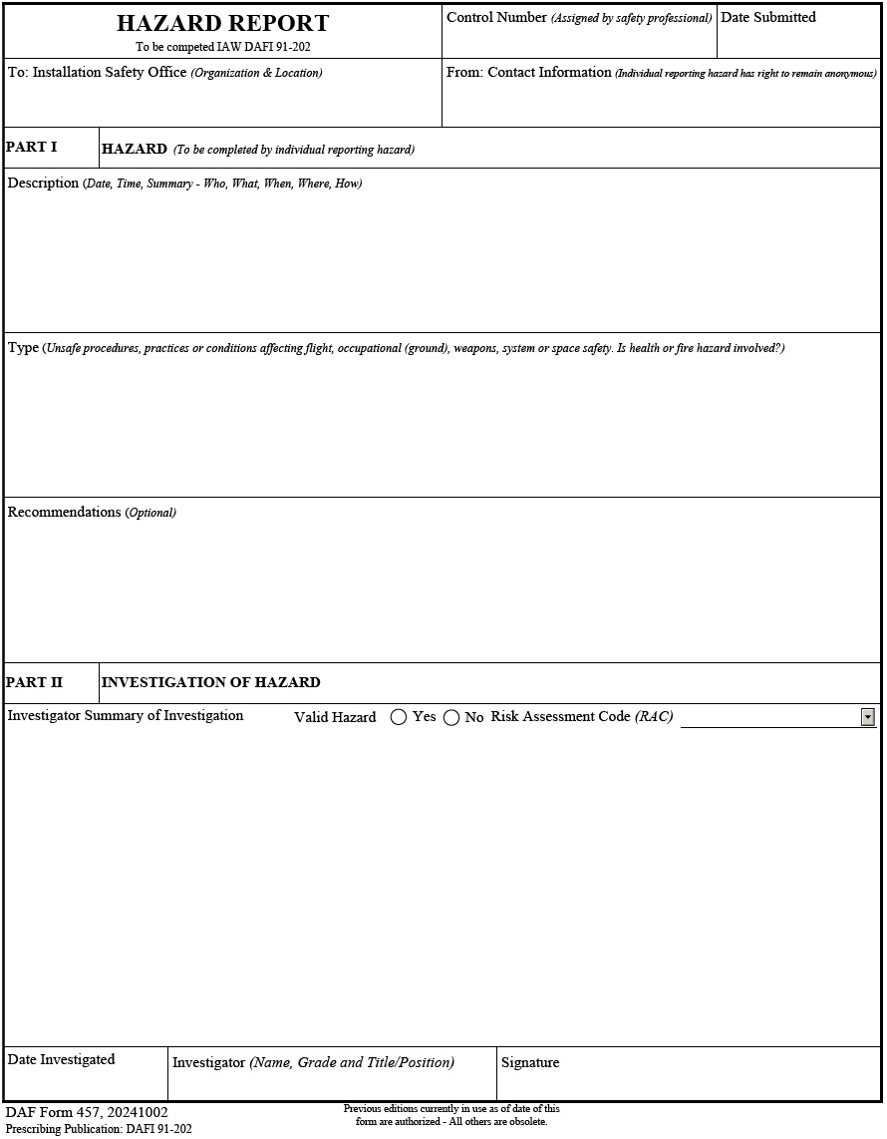

**SAFEREP Process**

Another avenue for reporting hazards anonymously is through the **SAFEREP APP**. SAFEREP is a voluntary, web-based system used to report process issues, equipment issues, hazards, etc. by Airman in all functional areas. To submit a report, visit <https://saferep.safety.af.mil>

5. Requirements for reporting mishaps, injuries, illnesses and OSHA recordable events

**Airman** will promptly report on and off duty injuries or damage to government property to their supervisor. If you have questions as to what you should report please call the Safety office at 92nd 247-2141 and/or 141st 247-7027/8.

**Civilians** will report all on-duty mishaps, but off-duty civilian mishaps are non-reportable.

The **DAF Form 978**, *Supervisor’s Preliminary Mishap/Incident Report* shall be used to document Ground mishaps/incidents. The involved/injured personnel’s **supervisor** shall complete the form, route it through the commander, and return it to the installation safety office within five (5) workdays following notification. The DAF Form 978 will be sent to the Wing Safety Office org box (92arw.seg.all@us.af.mil or 141_ARW/SE).

**Location of medical facilities & procedures for obtaining treatment:**

The on base medical facility is the 92nd Medical Group located in building 9000. Their main line *non-emergency* phone number is 509-247-2361.

**Emergency procedures which apply to the work center:**

Add additional emergency procedures specific to your work center here.

**Means to summon emergency services:**

**Note:** Calling 911 from a cell phone gets you Spokane County 911 center. You must tell them you need FAFB 911 and they will transfer you.

92nd Fire Department …….... 509-247-5215

92nd Security Forces ……….. 509-247-5493

92nd CE Environmental ……. 509-247-8155

92nd Bioenvironmental …… 509-247-2391

**Evacuation routes and meet-up points:**

Add evacuation routes and meet-up points specific to the facilities or areas you work in.

**Shelter in place locations:**

Add shelter-in-place locations specific to the facilities or areas you work in.

**Active shooter response methods:**

Add active shooter response methods specific to the facilities or areas you work in.

6. Purpose and location of CA-10 and form LS-201 if applicable

CA-10, What a Federal Employee Should Do When Injured at Work

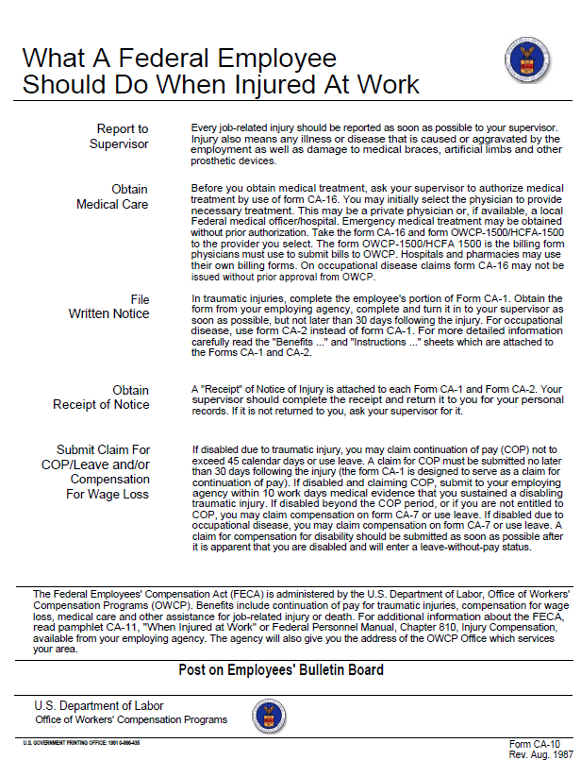

LS-201, Notice of Employee’s Injury or Death

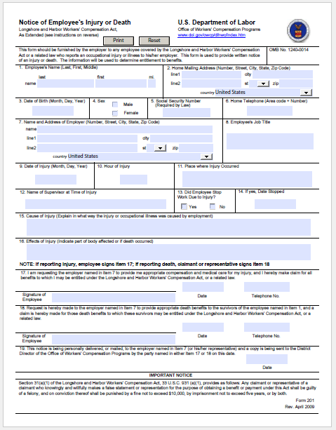

7. Requirements of the Air Force Traffic Safety Program (DAFI 91-207)

**Seatbelts**

Seatbelts are required to be worn on base in military and civilian vehicles so equipped. In addition, child restraint systems or booster seats shall be used as prescribed by the manufacturer. Washington state law requires mandatory use of seat belts by all passengers in any vehicle so equipped off base.

**Helmets**

Helmets are required for all persons who ride a bicycle, tricycle or other human powered vehicle, including motorized bicycles.

**Motorcycles**

Military riders are required to identify themselves to their Unit Motorcycle Safety Representative (MSR). Riders must complete training, document training in the Motorcycle Unit Safety Tracking Tool (MUSTT) located in the Air Force Safety Automated System (AFSAS), and utilize relevant PPE as directed by DAFI 91-207 and manufacturer’s instructions.

**Base speed limits**

On Base - 30mph (Unless otherwise posted)

Main Gate/In front of fitness center/School area - 20 MPH

Base Housing/ Flight line (General) - 15 MPH

**Local area traffic hazards**

-Multiple roundabouts in the area

-Wildlife such as deer, turkey, porcupine. etc. are common on local roads

-Seasonal temperatures lead to icy/slick road conditions

**Spotters while backing**

Backing of government-owned motor vehicles and the usage of spotters will be accomplished in accordance with DAFI 91-207, paragraph 3.2 and AFMAN 24-306, paragraphs 4.13 and 4.14.

**Vehicle training requirements**

Vehicle training requirements will be accomplished in accordance with AFI 24-301 and AFMAN 24-306.

**Electronic devices**

Vehicle operators on an AF installation and operators of government owned, leased, or rented vehicles, on/off an AF installation, shall not use cell phones or other handheld electronic devices while the vehicle is in operation, except when using a hands-free device or hands-free operating modes.

8. Location and content of Air Force Visual Aid (AFVA) 91-209

Provide the location in your facility of the posted Air Force Visual Aid (AFVA) 91-209.

Location: Add where this is posted in your facility

9. Air Force Safety Management System (AFSMS) Responsibilities

Discuss how leaders, supervisors and airmen will participate in the unit safety management system and work towards continual improvement. (See paragraph DAFI 91-202, paragraph 13.1)





Job specific training items: DAFI 91-202, para 14.1.3

Supervisors will provide specific training based on the program requirements of the work place, provide application-level training, and document prior to employee performing task. If the Career Field Education Training Plan (CFETP) covers a particular training program, then no additional documentation beyond the CFETP is required. **Note:** Subjects listed below may not be mandatory for every job, but are dependent upon the type of job/task individuals will be performing. Items listed below may not be all inclusive, refer to specific program requirements.

14.1.3.1. Hazardous Energy Control. Reference: 29 CFR §1910.147 and DAFMAN 91-203, Chapter 21, Hazardous Energy Control.

14.1.3.2. Hazard Communication. Reference: AFI 90-821, Hazard Communication, and 29 CFR § 1910.1200.

14.1.3.3. Bloodborne Pathogens. Reference: 29 CFR § 1910.1030.

14.1.3.4. Hearing Conservation. Reference: AFI 48-127, Occupational Noise and Hearing Conservation Program.

14.1.3.5. Confined Space Program (Entrant, Attendant, Supervisor, Monitor and Rescue Team). Reference: DAFMAN 91-203, Chapter 23, Confined Spaces, and 29 CFR § 1910.146.

14.1.3.6. Manual and Powered Hoists. Reference: DAFMAN 91-203, Chapter 35, Material Handling Equipment.

14.1.3.7. Respiratory Protection Program. Use AF Form 2767, Occupational Health Training and Protective Equipment Fit Testing (LRA). Reference: AFI 48-137, Respiratory Protection Program.

14.1.3.8. Vehicle Mounted Elevated Work Platforms, Self-Propelled and Manual Platforms. Reference: DAFMAN 91-203, Chapter 16, Mobile Elevating Work Platforms.

14.1.3.9. Fall Arrest System(s). Reference: DAFMAN 91-203, Chapter 13, Fall Protection, 29 CFR 1910.66 and 29 CFR 1926.503.

14.1.3.10. Forklift (Material Handling Equipment). Reference: DAFMAN 91-203, Chapter 35, and 29 CFR 1910.178.

14.1.3.11. Explosives Safety Training. Reference: DESR6055.09_DAFMAN91-201_DAFGM2024-01, Explosives Safety Standards, and this instruction.

14.1.3.12. Pole/Tower Climbing. Reference: DAFMAN 91-203, Chapter 30, Communication Cable, Antenna and Communication Systems.

14.1.3.13. Cardiopulmonary Resuscitation (CPR) Training. Reference: DAFMAN 91-203, Chapter 1, Introduction.

14.1.3.14. Flight Line Driving. Reference: DAFMAN 91-203, Chapter 24, Aircraft Flight Line – Ground Operations and Activities, and other governing directives.

14.1.3.15. Fetal Protection Program. Job Specific. Reference: DAFMAN 48-146, Occupational & Environmental Health Program Management. Note: Air Force Reserve – AFRCI 41-104, Pregnancy of Air Force Reserve Personnel.

14.1.3.16. Medical Surveillance Examination (Scheduling, Administration, Reporting and Follow-up). Reference: DAFI 48-145, Occupational and Environmental Health Program.

14.1.3.17. Electromagnetic Field Training (EMF). Reference: AFI 48-109, Electromagnetic Field Radiation (EMFR) Occupational and Environmental Health Program.

14.1.3.18. Laser Safety Training. Reference: AFI 48-139, Laser and Optical Radiation Protection Program.

14.1.3.19. As Low As Reasonably Achievable (ALARA) Ionizing Radiation Training. Reference: AFMAN 48-148, Ionizing Radiation Protection.

Annual Supervisor Review: DAFI 91-202, para 14.1.1.1

If this is a Total Force Integrated (TFI) Job Safety Training Outline (JSTO) all supervisors will need to sign annually.

|  |  |
| --- | --- |
| RANK, NAME, AND SIGNATURE | DATE |
|  |  |
|  |  |
|  |  |
|  |  |
|  |  |
|  |  |
|  |  |
|  |  |
|  |  |
|  |  |
|  |  |

AIR FORCE OCCUPATIONAL SAFETY AND HEALTH STANDARDS

Safety Instructions

DAFI 91-202; US AF Mishap Prevention Program

DAFI 91-207; US Air Force Traffic Safety Program

DAFI 91-204; Safety Investigations & Reports

DAFMAN 91-203; AF Consolidated Occupational Safety Instruction

DAFMAN 91-224; Ground Safety Investigations & Reports

DESR6055.09_DAFMAN 91-201; Explosive Safety Standards

DAFMAN 91-221; Weapons Safety Investigations & Reports

DAFMAN 92-223; Aviation Safety Investigations and Reports

Environmental

DAFMAN 32-1084; Facility Requirements

DAFMAN 32-1053; Integrated Pest Management Program

DAFI 32-1065; Grounding & Electrical Systems

DAFI 32-7002; Environmental Compliance & Pollution Prevention

DAFPD 37-70; Environmental Considerations in Air Force Programs & Actives

DAFPD 90-8; Environmental, Safety and Occupational Health Management & Risk Management

DAFI 90-821; Hazard Communication

DAFI 90-901; Operational Risk Mgt

Forms

AF Form 3, Hazard Abatement Plan

AF Form 332, Base Civil Engineer Work Request

DAF Form 457, USAF Hazard Report

AF Form 55, Employee Safety & Health Record

AF Form 592, USAF Welding, Cutting and Brazing Permit

DAF Form 623, Individual Training Record Folder

AF Form 979, "Danger Tag"

DAF Form 978, Supervisor Mishap Report

AF Form 980, "Caution Tag"

AF Form 981, "Out of Order Tag"

AF Form 982, "Do Not Start"

DAF Form 1024, Confined Space Permit

AF Form 1118, Notice Of Hazard

AF Form 3952, Chemical/Hazardous Material Request/Authorization Form

DAF Form 4391, High Risk Activities Form

DAF Form 4392, Pre-departure Safety Briefing

DAFVA 91-209, Air Force Occupational Safety and Health Program Poster

CA-10, What a Federal Employee Should Do When Injured at Work

CA Forms; Civil Service Injury & Illness Forms

OSHA 3165-12-06R, Job Safety & Health, It‘s The Law